Romania - an Energy Pole in Europe

Romania ENERGY DAY in Brussels

Conference Proceedings

Date: 15 May 2013: 9:00 – 17:30
Venue: Representation of the State of Baden-Württemberg to the European Union,
Rue Belliard 60-62, B-1040 Brussels

Centrul Roman al Energiei are placereasava invite  Sa participate la Evenimentul “Romania an Energy Pole in Europe” in Bruxelles  Miercuri, 15 Mai 2013  9:00 – 17:30  Mesaje de deschidere la 9:15 |  | Romanian Energy Center is pleased to invite  you to attend the Event “Romania an Energy Pole in Europe” in Brussels  Wednesday, 15 May 2013  9:00 – 17:30  Opening speakers at 9:15
Session I - HIGH LEVEL OPENING KEYNOTES
8:45 – 9:15 | Welcome Coffee
Bun Venit |  | Welcome
Johannes JUNG  Director Reprezentanta Statului  Baden-Württemberg to the European Union |  | Johannes JUNG  Head of the Representation of the State of  Baden-Württemberg to the European Union
Stelian GAL  Presedinte  Centrul Roman al Energiei - CRE |  | Stelian GAL  President  Romanian Energy Center – REC – Welcome Message
E.S. Dl. Mihnea Ioan MOTOC  Ambasador Extraordinar si Plenipotentiar, Reprezentanta Permanenta a Romaniei pe langa Uniunea Europeana |  | H.E. Mr. Mihnea Ioan MOTOC - Welcome Message  Ambassador Extraordinary and Plenipotentiary, Permanent Representative of Romania to the European Union
Constantin NITA*  Ministru Delegat pentru Energie  Ministerul Energiei  Guvernul Romaniei  * Mesaj scris |  | Constantin NITA*  Delegate Minister for Energy  Ministry of Energy  Government of Romania  * Written message

 | Session II - ENERGY STRATEGY – The Quest for EU and Romania
 | Moderator: Valeriu BINIG – Director, DELOITTE - Presentation
10:00 – 10:20 | EU Strategy 2020 and long term Energy Priorities | Tudor CONSTANTINESCU  Principal Adviser  European Commission  DG ENER
10:20 – 10:40 | Building European Energy Infrastructure | Adina VALEAN  ITRE Cttee, European Parliament
10:40 – 11:00 | The Strategy of the Romanian Distribution System Operator – ELECTRICA S.A. | Ioan ROSCA  Director General  ELECTRICA S.A.
11:00 –11:30 | Panel Debate: The best options for sustainable energy | All speakers  Panelists:  Corneliu BODEA - Presentation  Vice President  Adrem Invest S.A.  Ion LUNGU - Presentation  President  Association of Electricity Suppliers in Romania
11:30 – 12:00 | Coffee Break
 | Session III – Energy Options – Romania as an EU Energy Pole
 | Moderator: Mihai PAUN - European Network of Transmission System Operators for Electricity
12:00 – 12:20 | Tools needed to guarantee Long Term Development of Electricity Transmission Infrastructure | Mihai PAUN  Network Development  ENTSO-E
12:20 – 12:40 | Long Term Transmission Grid Development in Romania | Stefan GHEORGHE  Director General  TRANSELECTRICA
12:40 – 13:00 | Natural Gas Transmission – Challenges and New Opportunities | Gabriela MARES  Deputy Director General  TRANSGAZ
13:00 – 13:30 | Panel Debate: Renewables – Future and Synergies | All speakers  Panelists:  George MANOLE  Director General  Eximprod S.A.  Stefan GADOLA - Presentation  Director General  Energobit S.A.  Gabriel ALDEA  Permanent Delegate to EU  SIVECO S.A.
13:40 – 15:00 |       Official Lunch sponsored by 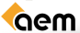
Session IV – A European Regional Energy Market Development and Challenges
 | Moderator: Jean CONSTANTINESCU - Energy Expert - Presentation
15:00 – 15:20 | South-Eastern European Energy Market – Views from BSEC Organisation | Nicholas EMIRZAS  Executive Manager  Organization of the Black Sea Economic Cooperation
15:20 – 15:40 | The Romanian Electricity Market – only for incumbents? | Niculae HAVRILET  President  National Energy Regulatory Authority - ANRE
15:40 – 16:00 | Romanian Power Market Perspectives | Mirela SANDULESCU  Head of Strategy Cooperation Office  OPCOM
16:00 – 16:45 | Panel Debate: Regional Energy Market – a step towards IEM | All speakers  Panelists:  Ion LUNGU - Presentation  President  Association of Electricity Suppliers in Romania  Mihai SANDULEAC - Presentation  Director  ECRO
CLOSING SESSION – KEY NOTE SPEECH
16:45 – 17:10 | EU External Energy Policy to Speak with One Voice: An Integral Part of the EU's Energy Policy | Günther OETTINGER  Commissioner for Energy  European Commission
17:10 – 17:20 | Final Questions
17:20 – 17:30 | Final Remarks | Stelian GAL  President  Romanian Energy Center - CRE
 | Kindly sponsored by

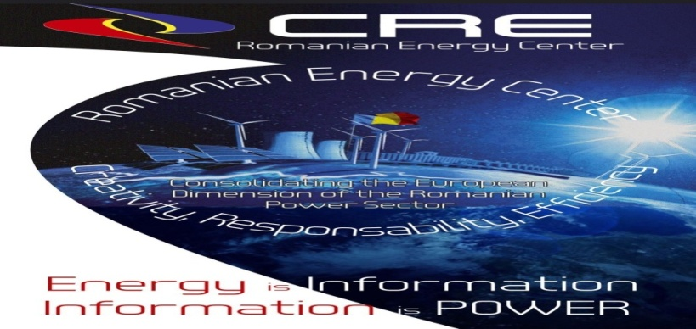
România
Centrul Român al Energiei – CRE • Str. Hristo Botev 16-18 • Cod: 030236• Sector1 • Bucuresti•România
Tel +4 021 3035 741 • Fax +4 021 3035 630 • office@crenerg.org •www.crenerg.org
Bruxelles
Romanian Energy Center – CRE • Rue Montoyer 23, B-1050Bruxelles
Tel +4 021 3035 741 • Fax +4 021 3035 630 • office@crenerg.org •www.crenerg.org

The Romanian Energy Center is a professional organization for Romanian energy companies.
It is managed andfinanced by its member companies, mainly the electricity companies at the present, and works to secure for them
the freest and most favourableconditions for competition and progress in order to ensure development, growth and well-being in Romania.

